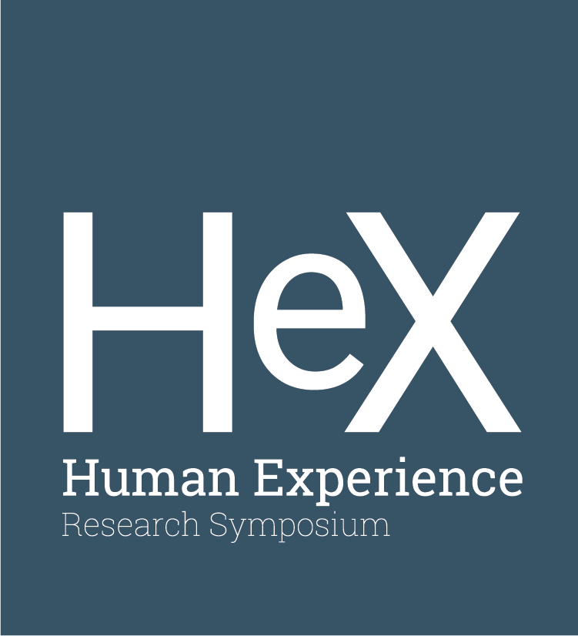
Human Experience Research Symposium Application

The Museum of Peoples and Cultures (MPC) is pleased to invite
BYU students from all majors interested in cultural aspects of the human experience to participate in the Human Experience (HeX)
Research Symposium on March 27, 2019. The purpose of the
symposium is to create a better understanding of the world
and our place in it, promote respect for world cultures, and inspire
people to value their connection to all peoples of the world,
including both local and non-local peoples.

Student participants will:
- Have the opportunity to present research,
methods and conclusions of research activities
- Learn valuable professional presentation skills
- Gain additional experience for your resume

Application Deadline: Monday, February 11, 2019, 11:59 p.m. (midnight)

Contact Information:

Name | Phone Number
E-mail | Major/Year in School

Research:

Presentation/Poster Title (Limit to 40 characters)
How would you prefer to present your research? ○ Poster ○ Presentation (10 minutes)
The HeX Review Committee will make every effort to accommodate preferences,
but reserves the right to assign presenters as the time and space allows.

Abstract: Write a 150-200 word description/summary of your project.

Expectations of Participants:
- Attend the orientation/presentation skills workshop on
Friday, March 1, 2019 (5:00 p.m. at MPC)
- Posters:
  - Submit your poster for final technical review and printing
by March 18 at 5:00 p.m.
  - Posters will be printed by the MPC and delivered to the HeX symposium.
- Presentations:
  - Prepare a 10 minute presentation explaining your research project and results.
You will have access to standard slide presentation equipment
with audio/visual capabilities.
- Attend the Symposium and be prepared to discuss your research and answer questions.

HeX Symposium Schedule: March 27, 2019
Paper session – 11:00 a.m. to 11:50 a.m. in WSC Garden Court
Poster session/Reception – 12:00 p.m. to 12:50 p.m. in WSC Garden Court
Paper session – 1:00 p.m. to 2:00 p.m. in WSC Garden Court

By submitting this application, I agree to attend the orientation/presentation skills workshop and the session in which I will present my research.

Submit application as a Word Document or PDF to mpc@byu.edu
Museum of Peoples and Cultures, 2201 North Canyon Rd, Provo, UT 84602
801.422.0022 – mpc.byu.edu

